https://evernote.com/clearly/

https://evernote.com/clearly/guide/#2

Getting Started with Evernote Clearly
- Introduction
- Read Distraction Free
- Save to Evernote
- Customize Evernote Clearly
- Other Resources

Read Distraction Free
Evernote Clearly gives you a distraction-free view of your favorite Web content at the click of a button. From blogs, to news articles, to reference materials and more, Evernote Clearly makes text cleaner and easier to read, so that you can focus on the content you care about without the ads, navigation and other distractions you don't.
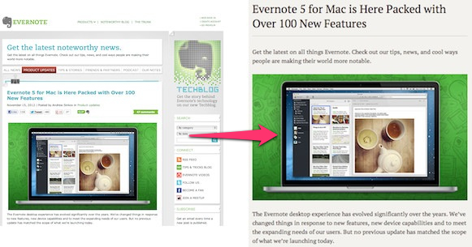

Using Evernote Clearly
To view a webpage using Evernote Clearly, simply click the Evernote Clearly icon next to the address bar in your browser window.
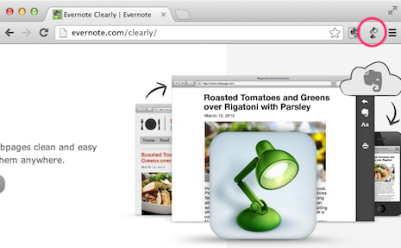
The main content of the webpage will be displayed free of ads, navigation and other distractions. All links, images and other media in the body of the content will be preserved and remain usable.

The Evernote Clearly Toolbar
In addition to making text clean and distraction-free, Evernote Clearly comes with a number of great additional features to improve your reading experience, including allowing you to highlight text, clip content to your Evernote account, print text, and customize text size and font.
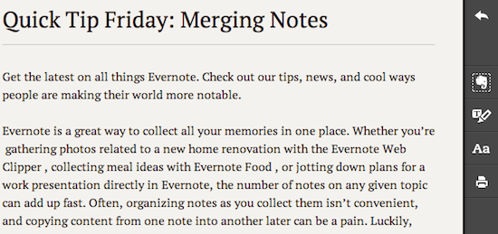
The following tools are available in the toolbar any time you view content in Evernote Clearly:
Return to Web View: Click to exit Evernote Clearly and return the normal Web view of the current content
Web Clipper: Click to clip all of the content currently displayed in Evernote Clearly into your Evernote account. Once the content is successfully clipped, a confirmation will be displayed. To open the content in Evernote, click the Edit button in the confirmation dialog
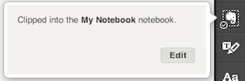
Highlighter: Click to enable the highlighter tool, then click and drag the text you want to highlight. Highlighted text will also be preserved when you clip the content into your Evernote Account
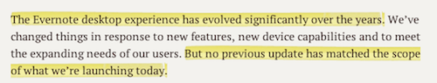
Adjust Text Size & Font: Click to choose a color theme, change the text size, or create your own custom theme for displaying content in Evernote Clearly
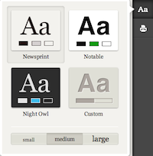
Print: Click to print

Related Notes
Related Notes are another great way that the Evernote family of products helps you remember everything. Anytime you view a webpage in Evernote Clearly, you will also be shown snippets from Related Notes in your Evernote account. To view a Related Note, click it to open it in Evernote.
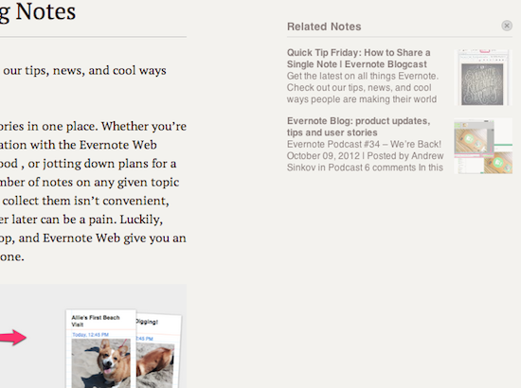

Save to Your Evernote Account
Similar to the Evernote Web Clipper, Evernote Clearly allows you to save content from the Web directly into your Evernote account, making it easy to capture useful information to read or reference later.
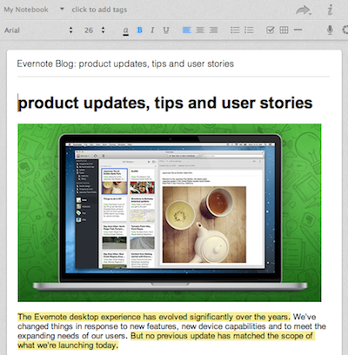
To clip the content currently displayed in Evernote Clearly, simply click the Web Clipper icon in the toolbar. If this is your first time using Evernote Clearly, you will be asked to log in to Evernote. Evernote Clearly will even automatically attempt to tag and save your clipped content to a related notebook thanks to the Smart Filing feature.

Next
Time to fully customize your reading experience with Evernote Clearly. Take a look at the available preferences next.
- Products
- Pricing
- Market
- App Center
- Support
- Blog
- About
- Careers
- Legal
- Terms
- Privacy
- Security
- API
- Contact
Copyright 2015 Evernote Corporation. All rights reserved.

Customize Evernote Clearly
There are a number of ways to customize your reading and Web Clipping experience with Evernote Clearly via the Preferences menu. Please be aware that the location of the Evernote Clearly Preferences menu may vary based on what version of your browser you are using.
To open the Preferences menu, do the following:
Chrome
- Mac: Click Window > Extensions, then click Options next to Evernote Clearly
- Windows: Click the menu icon to the right of the address bar and select Settings, then click Extensions in the left sidebar, and click Options next to Evernote Clearly
Firefox
- Mac: Click Tools > Add-Ons, then click the Preferences button next to Evernote Clearly
- Windows: Click Firefox > Add-Ons, then click Extensions in the left sidebar, followed by the Options button next to Evernote Clearly
Opera
- Mac: Click Window > Extensions
- Windows: Click the Opera menu > Extensions

Options
The following preferences can be set from the 'Options' tab:
Keyboard shortcuts: Assign custom keyboard shortcuts to some of the most used features in Evernote Clearly. The default keyboard shortcuts are displayed
Tags: Specify one or more tags to automatically be associated with any Web Clips saved to your Evernote account with Evernote Clearly
Notebook: Select whether Evernote Clearly should save clipped content to your default notebook, or a different notebook of your choosing
Smart Filing: Select whether Evernote Clearly should use Smart Filing to automatically predict tags, notebook or both when clipping content to your Evernote account. You may also disable Smart Filing
Related Notes: Select whether Related Notes should be shown, shown only at the bottom of the screen, or not shown when you view content in Evernote Clearly
Account: Displays the Evernote account that you are currently signed in with. Any Web Clips captured with Evernote Clearly will be saved to this account

Custom Theme
Evernote Clearly does more than just remove all of the distractions from content on the Web, it also gives you the ability to fully customize the look and feel of your reading experience.
The following preferences can be set in the 'Custom Theme' tab:
- Body Font: The font used to display body text
- Header Font: The font used to display content headers, such as article titles and section titles
- Monospace Font: The font used to display any monospaced text, such as code samples
- Background Color: The color that appears as the background behind text
- Foreground Color: The color that will be used for text
- Base Font Size: The font size that will be used for body text
- Line Height: The amount of vertical space between lines of text
- Line Width: The total horizontal width that text spans across the screen
- More Options: Click to view advanced formatting options, including CSS, text alignment, and image settings
Any changes you make to your custom theme will automatically be previewed in the displayed sample text, so you can easily see how your new settings will look in Evernote Clearly.

Next
Check out our other resources to get even more out of Evernote and Evernote Clearly.
- Products
- Pricing
- Market
- App Center
- Support
- Blog
- About
- Careers
- Legal
- Terms
- Privacy
- Security
- API
- Contact
Copyright 2015 Evernote Corporation. All rights reserved.
English (US)‎

Other Resources
Check out these additional resources to make the most of Evernote:

Technical Support
Search for answers to your questions, or contact the support team.

Evernote User Forums
Read or join other users' discussion about using Evernote.

Evernote Blog
Get inspiration from user stories and product announcements on Evernote's blog.
- Products
- Pricing
- Market
- App Center
- Support
- Blog
- About
- Careers
- Legal
- Terms
- Privacy
- Security
- API
- Contact
Copyright 2015 Evernote Corporation. All rights reserved.
English (US)‎

