SOFIA UNIVERSITY ROOMS:

Room 243, 2nd floor (see where the blue arrow is on the map).
This is where all the LECTURES in the English department are held.
Rooms MMR (Multimedia room), AVK (Audio Video Room) and the 5 phonetic labs are to be found opposite 243. Just across the corridor, there is a door with a staircase leading to another, hidden, floor. Go up the stairs and you will find those rooms.
Room 165 is in the main building, 5th floor. One of the elevators goes to the 5th floor; the other one goes to the 4th floor, so you need to walk up one floor.
Rooms 184, 185 and 186 are in the same place, but you need to climb an extra flight of stairs to the 6th floor just under the roof (no elevator leading there).
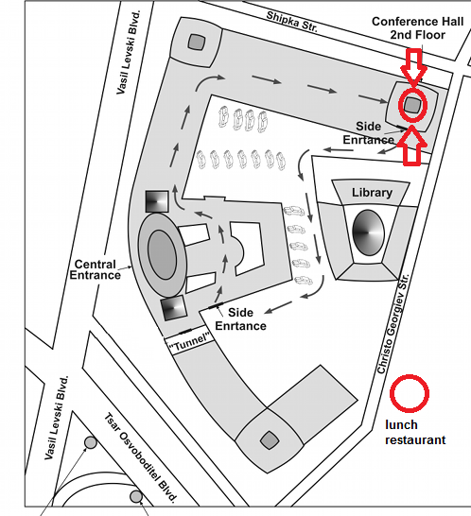
184, 185, 186
165
AVK, MMR, Phonetic labs
243

Follow the blue arrows and ignore the red signs; the map was taken from a conference info pack, so these palces are not relevant to you.

For block 1 and 3:
You need to take bus 280 and either get off at Pliska bus stop (the hotel in the photo) and walk past the yellow block seen behind the hotel and then some more, or you get off at the next stop (Studetnski obshtezhitia) and go straight to block 1 and 3 from there. If you are travelling from Student’s Town, you are on the right side of the boulevard. If you are coming from Sofia University, take the underground to get on the other side (same side as the hotel).

