View this email in your browser

We are thrilled to present you with a curated list of AI tools specifically designed to enhance efficiency within your organization.
Top AI Tools to Enhance Your Research
Are you tired of spending countless hours on research, sifting through vast amounts of data? We have exciting news for you! Our team has curated a list of cutting-edge AI-powered research tools to revolutionize the way you gather information and uncover insights.
With the rapid advancements in artificial intelligence, conducting research has never been easier or more efficient. AI tools are designed to streamline your research process, saving you valuable time and providing accurate, comprehensive results.
Let's explore how these tools can benefit you:
- AJE Digital Editing: In our own operations, we increased efficiency by over 200% after adding digital AI services into our organizational workflows. Want to learn more? Click here to talk to one of our AI experts.
- GanttPRO is a research planning tool to create a timeline, tasks, follow progress and deadlines.
- Paper Digest creates 3-minute summaries of research papers by extracting key ideas and sentences.
- Excel Formula Bot converts your text instructions into a spreadsheet formula.
- Endnote: Researchers waste nearly 2,00,000 hours/year formatting citations! This tool simplifies formatting bibliographies, finding impact of references and full texts.
Embrace the power of AI and unlock a world of possibilities for your research endeavors. Incorporating AI into your research workflow can save time, enhance productivity, and improve the overall quality of your work.
Read the full list here >>

Understanding Journal Submission Systems: How to Submit an Article for Publication in a Journal
Writing a Cover Letter for Journal Submission [Free Template]
What is a Good Impact Factor for a Journal?
Choosing the Right Journal for Your Research

From our friends at Nature
The Continuing Rise of Collaboration
Springer Nature’s new white paper, ‘A Changing Landscape in Collaboration,’ brings together insights from five Springer Nature experts on the changing nature of collaboration and how institutions are responding.
Read more >>
How geoscientists are making their field more welcoming
Grassroots initiatives aim to make the discipline more inclusive of researchers from under-represented communities.
Read more >>
How scientists are using WhatsApp for research and communication
The messaging tool can help to reach collaborators and study participants in areas where Internet connectivity is poor.
Read more >>
How AI is helping the natural sciences
Collaborations across disciplines are growing, and artificial intelligence is helping to make joint working more effective.
Read more >>
Nature Masterclasses: Writing a Research Paper
Access a free sample from Nature Masterclasses. In this free course, you’ll learn how to write an effective article that will appeal to a broad audience as well as attracting the attention of your peers.
Read more >>

The Research Square BlogSpot
- Making a Great Video Abstract [examples and critique]
- Using Data Sources in Research
- What is Missing Data Bias?
- 10 Most Common Types of Plagiarism (and How to Avoid Them)
- How to Gauge the Credibility of Preprints

Special Offer: Try AJE’s Figure Formatting Service For Free
AJE’s team of expert editors can help you improve the clarity and readability of your figures, ensuring your data is presented in a professional and visually appealing manner. With AJE’s comprehensive figure formatting service, you can trust that your figures will meet the highest standards of accuracy and quality.
For a limited time, try Figure Formatting for free. Enter the code "FIGURE23" when placing your order before May 30th to take advantage of our special discount. Don't miss this opportunity to enhance the presentation of your research findings.
Get started >>

About AJE
AJE, a part of Springer Nature, exists to make research communication faster, fairer, and more useful. Through English editing and our comprehensive suite of author services, we are proud to have supported over 2.5 million researchers in 192 countries since our founding in 2004. By helping researchers achieve publication success, we accelerate the pace of global discovery and advancement.
For more information on our services and partnership opportunities, visit AJE.com.
Refer your colleagues and receive a $40 discount for each one who makes a purchase with AJE
Copyright © 2023 Research Square (Research Square Author Services). All rights reserved.
Research Square Company
601 W Main St Ste 102 Durham, NC, 27701, US
Want to change how you receive these emails?
You can unsubscribe from this list.
We respect your right to privacy - view our policy

https://secure.aje.com/en/researcher/submit/get-started
Try figure formatting for free.

Your goal
Knowing your end goal helps us determine the services that are right for your order.
Improve my manuscript
Improve my figures or tables
Improve my grant application
Improve my thesis
Improve my academic book

Your files
Upload your files to see custom pricing and services based on your file type, word count, and area of study. Common files include manuscripts, figures, and grant applications.

I will upload my files later

https://masterclasses.nature.com/writing-a-research-paper/16605458?utm_source=sfmc&utm_medium=email&utm_campaign=May%202023%20b2b%20admin
For students and researchers in the natural sciences who are new to scientific writing or wish to improve the quality of their written output
Taught by 17 Nature Portfolio journal Editors
4.5 hours of learning
15-minute lessons
6-module course with certificate

About this course
'Writing a Research Paper' focuses on how to write an effective, clear and concise article that will appeal to a broad audience as well as attracting the attention of your peers.

What you'll learn
- What editors look for in a great paper
- How to write clearly, develop a great title and abstract, and structure your paper
- How to manage and present your data

https://www.researchsquare.com/blog/ai-tools-for-research?utm_source=sfmc&utm_medium=email&utm_campaign=May+2023+b2b+admin

author resources

AI Tools to Help with Research

Research takes time and resources. Take advantage of our list of AI tools to help you save time when conducting research.

Posted May 2, 2023 by Gareth Dyke, PhD
Are you a PhD student or researcher? Here are some AI tools you can use at various stages of your research:

Academic Writing
- AJE Digital Editing: an AI digital editing tool trained on 300,000+ manuscripts from more than 400+ areas of study and over 2000 field-specific topics.
- Grammar Check: a grammar checker and language correction AI tool for academic and technical writing; finds errors unique to academic writing that other grammar checker tools may miss.
- Lex: a text editor which helps you neatly store and format documents with simple prompts including references, headers and bulleted lists
- Scrivener: a tool for long writing projects. It helps you fight page fright and writer's block by letting you write text in any order and find its place in the thesis later. It’s helpful in keeping your notes organized.

Research planning
- GanttPRO: A research planning tool to create a timeline, tasks, follow progress and deadlines.

Finding & synthesizing literature
- Semantic Scholar: Get access to 200 million research papers, discover links between topics, get recommendations based on recent searches and generate summaries.
- Scholarcy: AI powered article summarizer which identifies key info like participants, data analysis, main findings and limitations
- Paper Digest: creates 3-minute summaries of research papers by extracting key ideas and sentences
- Content Mine: enables you to find, download, analyze, and extract knowledge from academic papers
- Elink.io: enables you to save the content from around the web: articles, videos, cloud files, social media posts and share them with peers.
- Elicit: helps you find relevant papers without perfect keyword match, summarize takeaways from the paper specific to your question, and extract key information from the papers
- Scite: allows researchers to see how a publication has been cited by providing the context of citation and discovering supporting and contrasting evidence for each paper
- SciSpace Copilot: a multi-lingual AI tool that helps you comprehend the paper (and the math and tables in it), seek answers to your queries, turn lengthy texts and sections into easy to consume summaries.

Data analysis
- Excel Formula Bot: converts your text instructions into a spreadsheet formula

Citations/Bibliography/Referencing
- Endnote: Researchers waste nearly 2,00,000 hours/year formatting citations! This tool simplifies formatting bibliographies, finding impact of references and full texts.
- Mendeley: creates references, citations, and bibliographies in multiple journal styles

Final thoughts
These tools do not aim to write your thesis or paper, but enable you to optimize your time and resources as you do your research.
https://www.aje.com/arc/how-to-submit-an-article-for-publication-in-a-journal/?utm_source=sfmc&utm_medium=email&utm_campaign=May+2023+b2b+admin

Understanding Journal Submission Systems: How to Submit an Article for Publication in a Journal
- Article
- Writing
- Journals
- Research Process
Electronic manuscript submission and peer-review systems have become indispensable in the modern era of academic research. Learn how to submit an article to a journal for publication.
Updated on October 10, 2022

Electronic manuscript submission and peer-review systems
Electronic manuscript submission and peer-review systems have become indispensable in the modern era of academic research. A majority of scholarly journal publishers employ these systems to facilitate rapid and seamless communication between editors, authors, and reviewers. These manuscript submission systems are secure and are designed to save time and resources of all involved parties. By simply logging into these software, authors can track the status of their submitted manuscript. Reviewers can enter their comments and recommendations as per their convenience. Moreover, editors can also oversee the entire process and add their comments to the article.
Using these manuscript submission systems is rather uncomplicated. The instructions can be found on the journal's website, usually in the ‘author information' page or on a different section pertaining to submission guidelines. The process of submission on all such software, be it ScholarOne or Editorial Manager, is similar, with minor differences in the checklists or required information.

Preprints and In Review
It is well-known among academics that the journey from manuscript preparation and submission to publication is a long and tedious one. To overcome this challenge, authors now resort to preprints, which are the newest integrations within these submission systems.
A preprint is the final version of a research manuscript that authors publicly share on preprint platforms, prior to peer-review and publication in the journal of their choice. Most preprints have a digital object identifier (DOI) number and therefore can be cited in other papers. This saves a substantial amount of time and leads to increased visibility of the research and author.
Since the manuscript is public and is not locked-in with a particular journal, preprints offer authors the advantage of having their work reviewed and commented on by experienced peers in their field from around the globe. If a preprint is weak and is critiqued publicly, it provides the opportunity for the author(s) to make changes prior to peer review and journal submission.
Research Square and Springer Nature have partnered to provide a free preprint service, called In Review, that integrates with over 700 Springer Nature journals. Through In Review, an author can publish their paper as a preprint when submitted to an integrated journal, receive feedback from researchers around the globe, track the status of the peer-review, and have their manuscript cited before it's published to the target journal. There are many benefits to posting your research as a preprint. A few other preprint servers are:
1. Advance: a SAGE preprint server for humanities and social sciences research
2. SSRN: an open-access online preprint community owned by Elsevier
3. Preprints: a multidisciplinary preprint platform owned by MDPI
4. Zenodo: an open-source, general-purpose preprint repository
5. MedRxiv: a preprint server for the medical sciences co-founded by Cold Spring Harbor Laboratory, Yale, and BMJ

Finding the right journal
Although writing a perfect research manuscript is an important factor in the process of publication, choosing the correct journal tops every element in the list. The journal in which your research gets published is your portfolio; it influences almost everything in your career, from collaborations to job prospects and fundings. The top five factors to consider while choosing the perfect journal are:
(1) Shortlist a few target journals, if not one, while drafting your manuscript
(2) Ensure that the aims and scope of the journal align with your research question
(3) Ensure that the journal publishes peer-reviewed research
(4) Check the novelty of your research by reviewing the publication history of the journal
(5) Check the average time the journal takes to publish and whether you can opt for open-access publication
If you're still not sure of the perfect journal for your research, check out JournalGuide, our free tool developed solely to help researchers make the best-informed decision and choose the correct journal for their manuscript.

Tips for polishing your manuscript before submission
Writing a research paper can be an overwhelming task, especially because after hours of writing, things may simply stop making sense. However, most journals are strict about the text being clear and non-redundant and meeting the journal guidelines; your manuscript could be rejected on this basis. If you tend to struggle with polishing your manuscript, here are a few quick tips that will help:
- Read as your reader: Firstly, after finishing your draft, take a break and get back to it. Next, look at your paper from a reader's perspective. This will give you a fresh pair of eyes. By keeping your target audience in mind, you will be able to check the accuracy of scientific terminology, cut down jargon, and write for someone who does not know the research topic as well as you do.
- Declutter: This is a crucial step! As you follow step 1, keep an eye out for deviation from the main topic and delete any unnecessary words or redundant statements.
- Grammar and punctuation: As you proofread your manuscript, thoroughly check whether you have used the correct punctuation marks. Check your periods, commas, colons, semi-colons, en dashes, and em dashes. It's important to keep grammar in mind while proofreading, particularly, ensuring that the verb tense is proper for a smooth flow. Use the past tense in the methods and results to report what you did and found. Use the present tense while stating information that has already been proven to be true.
- Follow journal guidelines: Adhere to the formatting requirements of the target journal, which can be found in the ‘author guidelines' page on the website. As you draft your paper, ensure the word count is within limits, all information needed in the title page and/or cover letter is included, the figures and/or tables follow the guidelines, and the references are formatted appropriately, along with other general requirements. Most importantly, check whether your journal follows a single- or double-blinded peer review process.
- Hire a professional editor: It's always a great idea to hire a professional editor in your field of study to communicate your research clearly and accurately, and ensure all the above steps are followed. An editor will provide top-notch language and scientific editing, i.e., they will polish your manuscript and correct grammatical errors, along with improving scientific terminology. If you're unsure of where to look, check out our editing services!

General steps to online journal submission
After you have chosen your target journal, written your research manuscript, and formatted the paper as per the journal's guidelines, it's now time to begin the process of submitting your paper to the journal. Here are a few points to remember:
- Be prepared: The submission system might require some information regarding your paper; therefore, it is helpful to have this handy. Ensure that you have the names, affiliations, and email addresses of all co-authors; the title, abstract, and cover letter; along with the conflict-of-interest statement, funding statement, and other general declarations, before you begin the submission process.
- Register or log-in: If you are using an online system for the first time, you will need to register into the system and remember your log-in details for use later.
- Uploading the files: At this stage, you will be asked to upload your manuscript, along with any additional files, such as supplementary material, figures, and/or tables. The guidelines provided for authors specifies the type of file you need to upload. Additionally, you might need to upload forms or statements of declaration. Please check the guidelines for more information.
- Check the reviewer's comments: After manuscript submission, if the reviewer(s) and editor require changes in your paper, you must provide a point-by-point response to each of their questions/suggestions. It would also be helpful to highlight all changes made in the manuscript for a swift decision on your revised manuscript.
- Track your manuscript: By logging-in, you can track the status of your submitted manuscript through the reference number provided at the time of submission. Once your paper is accepted, you can share it on different platforms and promote it to increase visibility and make way for future collaborations.

General mistakes to avoid during manuscript submission
Lastly, I have compiled a checklist to follow while submitting your manuscript.
- Manuscript text: Ensure the text is clear, concise, and within the scope of the journal.
- Journal formatting: Take some extra time to adhere to the journal guidelines.
- Blinded manuscript: Ensure your manuscript follows the single- or double-blinded criteria
- Statements of declaration: All authors must submit all required statements of declaration.
- File types: It is important to submit files of the required type, especially for figures and tables.
- Response to reviewers: Provide a point-by-point response to the reviewers, even when you disagree with the comment or suggestion. Ensure professionalism and be less emotive in your responses.

Final thoughts
Writing and submitting your research manuscript may seem like a daunting task, but if taken one step at a time, it can be straightforward. Preprints offer immense benefits to an author and are worth considering. I hope you make use of the information provided in this article while submitting your next manuscript. Good luck!
Contributors

Lubaina Koti, BS
Scientific Writer

Tag
Table of contents
Share+
Join the newsletter
Sign up for early access to AJE Scholar articles, discounts on AJE services, and more

Email

See our "Privacy Policy"

Ready to submit to a journal?
Our Journal Recommendation service recommends three of the most suitable publications for your work.

Professional
Automated tools
Formatting
Funding services
Resources
Solutions
Company
https://www.aje.com/arc/writing-cover-letter/?utm_source=sfmc&utm_medium=email&utm_campaign=May+2023+b2b+admin

Writing a Cover Letter for Journal Submission [Free Template]
- Guide
- Writing
- Research Process
- Peer Review
- Journals
- Visibility
Journal cover letters are your chance to lobby on behalf of your manuscript. This AJE Journal Cover Letter Guide offers some useful tips for getting them right. It also includes a free journal cover letter template.
Updated on September 20, 2018
The cover letter accompanying your journal submission is your chance to lobby on behalf of your manuscript. The letter is far from just a formality and should be written with the same care as your manuscript's text (if not more). Ultimately, your cover letter is designed to influence the decision of the editor to send your manuscript out for peer review. The letter will argue that your manuscript is a good fit for the journal you are submitting it to and highlight your most important findings. Let us help you produce the most effective cover letter possible.
Getting ready to submit your manuscript? Download our comprehensive Free Journal Cover Letter Writing Guide with Template.

A cover letter should be written like a standard business letter:
Address the editor formally by name, if known. Include your contact information, as well. This information is probably available through the journal's online submission system, but it is proper to provide it in the cover letter, too.
Begin your cover letter with a paragraph that states the name of the manuscript and the names of the authors. You can also describe what type of manuscript your submission is (research article, review, case report, etc.). In this first paragraph and the next, describe the rationale behind your study and the major findings from your research. You can refer to prior work that you have published if it is directly related.
Next, write a short paragraph that explains why your manuscript would be a good fit for the journal. Do not simply state that your manuscript is “of interest to the field” or “novel.” Address specific aspects of the journal's Aims & Scope statement. If the journal expresses interest in research with a clinical application, be sure to highlight the importance of your work in terms of clinical implications. If the journal mentions that it focuses on nanostructured materials, explain how your work involved such materials. Even if your work is not a perfect fit for the journal, be sure to address some of the Aims & Scope statement, and explain why your manuscript would be of interest to the journal's readers.
Finally, close with a brief paragraph indicating the following:
- The manuscript is original (i.e., you wrote it, not copied it)
- No part of the manuscript has been published before, nor is any part of it under consideration for publication at another journal
- There are no conflicts of interest to disclose
- A list of potential reviewers (only if requested by the journal)
- Any researchers who should NOT review your manuscript
Together, this information provides assurance to the editor that your manuscript merits consideration for publication in their journal and that you are interested specifically in their journal. Sometimes great science will be reviewed regardless of the cover letter, but a well written cover letter is useful for the vast majority of scientists who want to make their research stand out.
Best of luck with your research! If you have any questions about your cover letter, write us anytime.
Contributors

Ben Mudrak, PhD
AJE Author

Tag
Table of contents
Share+
Join the newsletter
Sign up for early access to AJE Scholar articles, discounts on AJE services, and more

Email

See our "Privacy Policy"

Cover Letter for Journal Submission Templates
Download a Microsoft Word template for a standard journal cover letter (also available with instructions in Chinese, Japanese, Korean, Portuguese, and Spanish).

https://www.aje.com/arc/what-is-a-good-impact-factor-for-a-journal/?utm_source=sfmc&utm_medium=email&utm_campaign=May+2023+b2b+admin

What is a Good Impact Factor for a Journal?
- Article
- Journals
- Research Process
A good journal impact factor (IF) is often the main consideration for researchers when they’re looking for a place to publish their work. Many researchers assume that a high impact factor indicates a more prestigious journal.
Updated on May 16, 2023
A good journal impact factor (IF) is often the main consideration for researchers when they’re looking for a place to publish their work. Many researchers assume that a high impact factor indicates a more prestigious journal. And that means more recognition for the manuscript author(s).
So, by that logic, the higher the impact factor, the better the journal, right?
Well, it’s not that simple.
In principle, a higher IF is better than a lower IF, but there are many conditions, variations, and other issues to consider.
There’s no single determinant of what makes a good journal impact factor. It depends on the field of research, and what you mean by “good.” What is “good” for a breakthrough immunology study may not apply as “good” for an incremental regional economics study.
Using impact factors in the academic world to rank journals remains controversial. The San Francisco Declaration on Research Assessment (DORA), for example, tried to tackle the issue of over-reliance on journal IFs when evaluating published research.
Yet researchers continue to associate a good IF with better quality research. So, until DORA or others develop a better solution, we’re stuck with the IF, simplistic as it may be.
Read on to increase your understanding of impact factors and learn what’s a good one for your research.

First, what’s an impact factor?
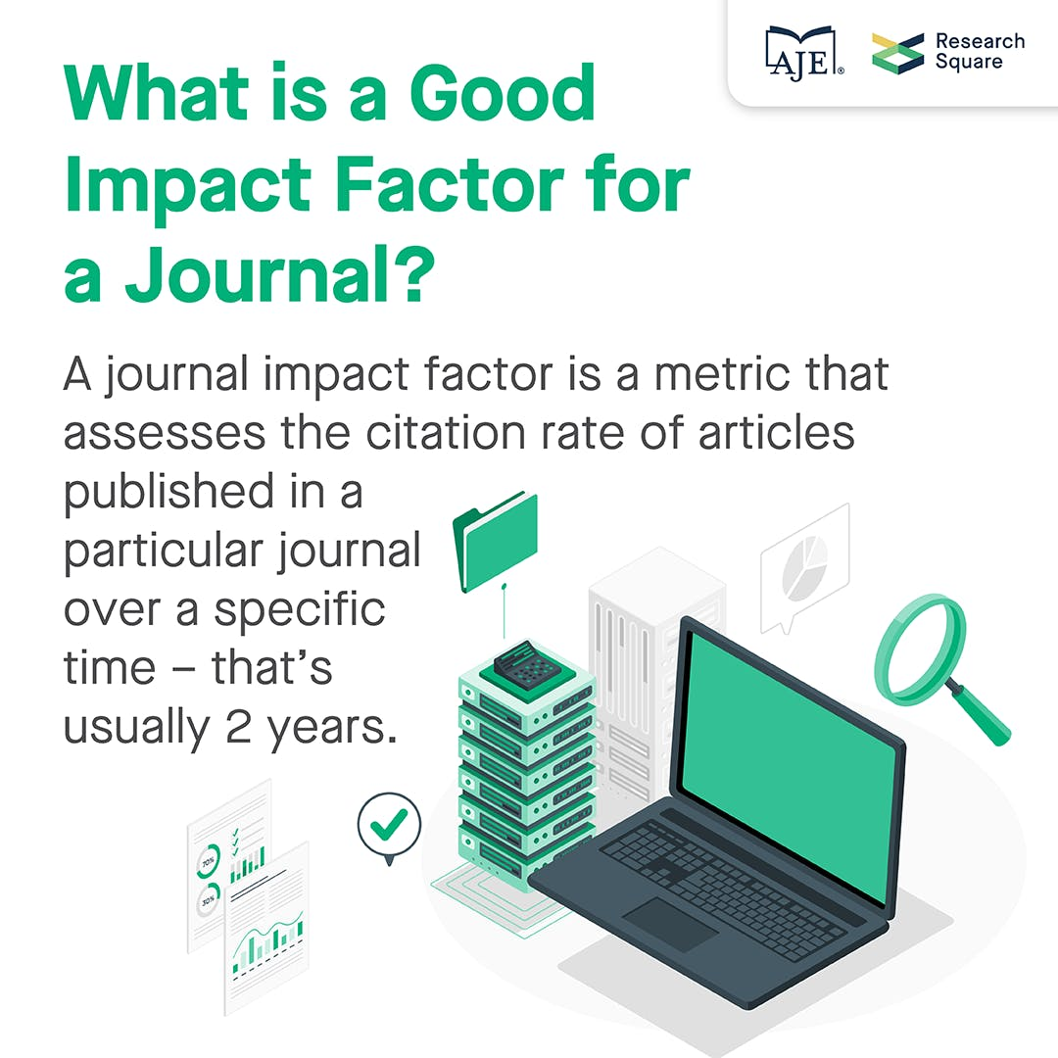
A journal impact factor is a metric that assesses the citation rate of articles published in a particular journal over a specific time – that’s usually 2 years (see below).
For example, an IF of 3 means that published articles have been cited on average 3 times during the previous 2 years.

How impact factors are calculated
The IF for a particular year is calculated as the ratio of the total times the journal’s articles were cited in the previous 2 years to the total citable items it published in those 2 years.
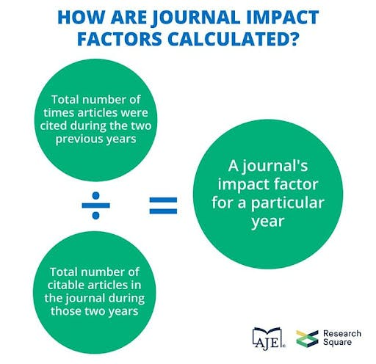
For example, in 2018, Nature had an IF of 43.070. That's a good journal impact factor. This is calculated as follows:
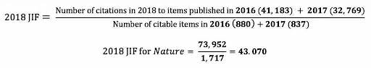
(Adapted from https://clarivate.libguides.com/jcr)
(Source: 2018 Journal Citation Reports)
Clarivate Analytics annually computes IFs for journals indexed in Web of Science. These scores are then collectively published in the Journal Citation Reports (JCR) database.
Clarivate publishes two different JCR databases every year. The Science Citation Index (SCI) is for the STEM (science, technology, engineering, and mathematics) disciplines, and the Social Science Citation Index (SSCI) is for, you guessed it, the social sciences. These are the only acceptable and reputable sources for impact factors out there: If your journal is using another index, then beware – it could be predatory.

Types of impact factors and metrics
In addition to the 2-year impact factor, Clarivate offers metrics for short-, medium-, and long-term analysis of a JCR journal’s performance. These metrics include:
- Immediacy index – Average number of times an article is cited during the same year it’s published.
- Citing and cited half-life – Median age of citations produced and received by a journal, respectively, during the current JCR year.
- 5-year impact factor – Average number of times articles published in a journal during the past 5 years have been cited in the current JCR year.
- Eigenfactor Score (ES) – Similar to the 5-year impact factor; differences are that (ES) eliminates self-citations and considers the importance of citations received by a journal.
- Article influence score – Derived from the ES; measures the average influence of each article published in a journal.

Quartiles
Journal ranking within a specific subject category can also be indicated by quartiles. Many universities around the world prefer the use of these metrics rather than raw IF for selecting journals. Four quartiles rank journals from highest to lowest based on the impact factor: Q1, Q2, Q3, and Q4.
Q1 comprises the most (statistically) prestigious journals within the subject category; i.e., the top 25% of the journals on the list. Q2 journals fall in the 25%–50% group, Q3 journals in the 50%–75% group, and finally, Q4 in the 75%–100% group.
Numbers = status, and many authors, or their institutions, insist on publication in a Q1 or at least a Q2 journal.
An alternative ranking system, and one that is free to access, Scimago Journal & Country Rank, also uses quartiles. Be sure not to confuse the two.

OK, back to the main question: What’s a good impact factor?
As mentioned, separate JCR databases are published for STEM and social sciences.

Discrepancies in fields
The main reason is that there are wide discrepancies in impact factor scores across different research fields. Some of the likely causes for these discrepancies are:
- Differences in citation behavior in different research fields; e.g., review articles tend to attract more citations than research articles, and the tendency to cite books in the social sciences.
- Differences in types of research; e.g., interdisciplinary and basic research attract more citations than intradisciplinary and applied research.
- Differences in field coverage by JCR; e.g., more in-depth coverage of STEM fields compared with humanities and the social sciences.
To put things into perspective, data prepared by SCI Journal for the 2018/2019 journal impact factor rankings are shown in this table.
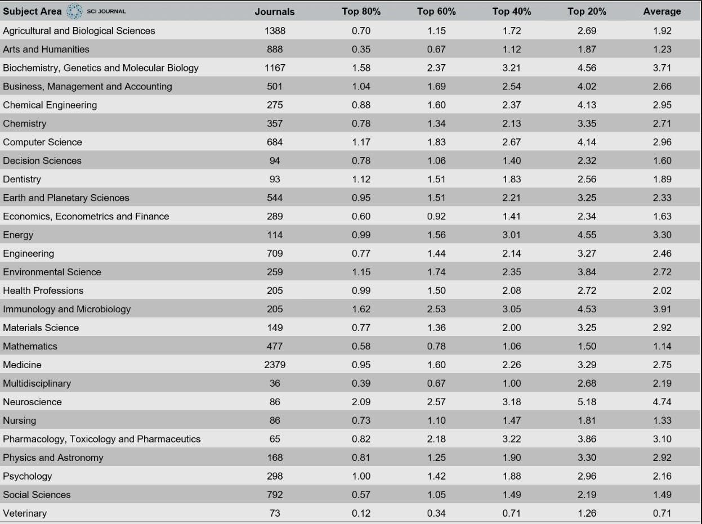
Source: scijournal.org
The table illustrates where a journal subject area ranks in the four classes: top 80%, top 60%, top 40%, and top 20%. Outliers were removed for the sake of cleaner data.

STEM impact factors
The data demonstrate how journals for subject areas show a range of impact factors.
Large fields, such as the life sciences, generally have higher IFs. They get cited more, so that makes sense. For example, it's natural that a study on a vaccine breakthrough will lead to more citations than a study on community development.
This obviously skews the use of impact factors when assessing researchers across a university. We can’t all keep up with the biologists!
For example, the top-ranked journal by Clarivate in 2019 was CA: A Cancer Journal for Clinicians, which had a remarkably high IF of 292.278. The New England Journal of Medicine, which has long been a prestigious journal, came in second with a high IF of 74.699. Those are amazingly good journal impact factors.
Conversely, reputable journals in smaller fields, such as mathematics, tend to have lower impact factors than the natural sciences.
For example, the 2019 JCR impact factors for respectable mathematical journals such as Inventiones Mathematicae and Duke Mathematical Journal were 2.986 and 2.194, respectively.

Social sciences impact factors
As for the social sciences, you could simply argue they’re “less popular” than the natural sciences. So, their reputable journals also tend to have lower impact factors.
For example, well-regarded journals such as the American Journal of Sociology and the British Journal of Sociology had JCR 2019 impact factors of 3.232 and 2.908, respectively. Those are good impact factors for the social sciences but would look rather low for STEM unless it was a regional or niche topic.
Therefore, what may be seen as an excellent impact factor in mathematics and the social sciences may be viewed as way below average in the life sciences.
That’s not to say the social sciences are less important. It just means they’re comparably researched and cited less.

Niche and specialized impact factors
The comparison doesn’t end there. Another aspect that shouldn’t be overlooked is the research subfield. Journals in, say, a physics subfield such as astronomy have a different impact factor than journals in fluid dynamics.
For example, two well-known astrophysics journals, MNRAS and Astrophysical Journal, had JCR 2019 IFs of 5.356 and 5.745, respectively. Meanwhile, two respectable journals in fluid dynamics, Journal of Fluid Mechanics and Physics of Fluids had JCR 2019 IFs of 3.354 and 3.514, respectively.
They may not be in The New England Journal of Medicine territory, but all are reputable journals.

So, all things considered, what is a good journal impact factor?
You have to look at the bigger picture here because there’s a lot more to consider than the single numeric representation.
If you’re in a field/subfield with high-impact-factor journals, it’s only logical that the cutoff for a good IF will also be high. And, of course, it’ll be lower for a field/subfield with lower impact factor journals.
Impact factor statistics should, thus, be interpreted relatively and with caution, because the scores represented are not absolute.
A good impact factor is either, in short, what your institution or you say it is. Otherwise, it’s one that's sufficient to connote prestige while still being a good forum for your research to be read and cited.
Let’s look at a few of the other factors, apart from IF, to help you choose your target journal.
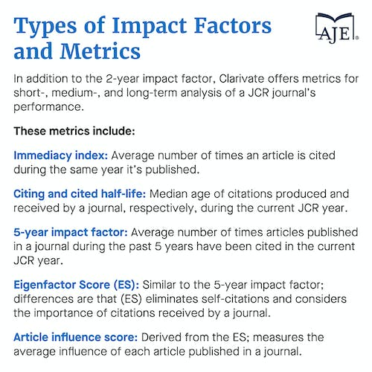

Pros and cons of using impact factor to judge a journal’s quality
The impact factor was used initially to rank journals, which will then help you decide on which one to which to submit your research. Some of the pros of an IF include:
- Easily accessible
- Gives a general picture of a journal’s prestige and reputation
- Is pretty good for comparison within a field if not across fields
- Appeals to people and institutions that like rankings and numbers
Despite its popularity, the impact factor is clearly a flawed metric, and its use to judge if a journal is good is criticized. That’s what we’ve seen with DORA, among plenty of others.
In addition to the previously mentioned shortcoming of not being able to use the impact factor for comparing journals across fields, other cons include:
- Ambiguous description of what “citable items” are
- Lack of consideration of highly cited papers resulting in skewed citation distributions
- Encouragement of self-citations by journals
The criticism is nothing new (see Kurmis, 2003, among others). But we’ve got to live with it until there’s something better.
On a personal note, we’re rather tired of seeing the great stress of publishing in a Q1 journal that’s placed on researchers. Especially those from certain economies that pressure their researchers to publish when they’d be better off fostering good, reflective, valuable research.
So here are some other factors with impact, even if they’re not impact factors.

Things other than impact factor to consider when choosing a journal
A good impact factor may be a requirement by your institution. But it shouldn’t be the only aspect you consider when choosing where to publish your manuscript.

Aims and scope
Another key factor is whether the work to be published fits within the aims and scope of the journal.
You can determine this by analyzing the journal’s subjects covered, types of articles published, and peer-review process. Some very targeted journals would welcome your research with open arms.

Target audience
An additional factor to consider is the target audience. Who is likely to read and cite the article? Where do these researchers publish? This can facilitate the shortlisting of some journals.

Other factors, apart from IF, for choosing your target journal
Other tips for choosing a journal include:
- Find journals that publish research that’s similar to yours, especially if it’s quite specialized
- Read as many published articles as you can in your target journal
- Go through your list of references to see which journals have the most citations
- Find out where fellow researchers and colleagues publish
Well-known publishers like Springer and Elsevier also list factors for choosing a journal.

Scimago as an alternative
Scimago Journal Rank (SJR), as mentioned above, is a useful portal that scores and ranks journals, which are indexed in Elsevier’s Scopus database, based on citation data.
The SJR indicator (PDF) not only measures the citations received from a journal but also the importance or prestige of the journal where these citations come from. It can be used to view journal rankings by subject category and compare journals within the same field.
And here’s a great scholarly article with useful references that provide information on how to identify and avoid submitting to predatory journals.

Conclusion on what’s a good impact factor, especially for you and your research
What makes a good impact factor boils down to the field of research and the host of arbiters of “good.” Highly reputable journals may have low impact factors not because they lack credibility, but because they’re in specialized/niche fields with low citations.
The interpretation of what is a “good” journal impact factor varies. Possibly due to the ambitious nature of some researchers or the ignorance of others.
An IF can indeed serve as a starting point during decision-making, but, if possible, and if you don’t have to meet some arbitrary target, more emphasis should be paid to publishing high-quality research.
The prevailing mindset should be that a journal stands to benefit more from the good-quality research it publishes rather than the other way around.
Contributors

AJE Team
The AJE Team

Tag
Table of contents
Join the newsletter
Sign up for early access to AJE Scholar articles, discounts on AJE services, and more
Top of Form
Email
Bottom of Form
Top of Form
See our "Privacy Policy"
Bottom of Form

Find the right journal for your work and with your desired impact factor
AJE will compile a report of three Journal Recommendations specifically for your scientific manuscript. This way, you can get pursue the impact factor you want and/or pursue which journal is most suitable or is likely to publish your work faster.
https://www.aje.com/arc/choosing-right-journal-your-research/?utm_source=sfmc&utm_medium=email&utm_campaign=May+2023+b2b+admin

Choosing the Right Journal for Your Research
Submitting a manuscript to an unsuitable journal is one of the most common mistakes made by authors, and both novice and seasoned researchers are capable of making this error. Considerations in the process include the journal's scope, any restrictions it imposes on manuscript types or topics, and the journal's Impact Factor.
Updated on September 19, 2018
Need help selecting a journal? AJE's team can work with you to identify top target journals, based on your specific article.
Publication in a peer-reviewed journal is the obvious goal of most research projects. It is through publication that your research reaches others in the field, advancing knowledge and encouraging communication between groups with similar research goals. Although peer review can be a lengthy and often exhausting process, the ultimate publication of your manuscript effectively validates your work and can help to advance your career, attract bright students and experienced staff, and garner funding for future studies. One of the most important—and possibly the least well understood—aspects of the publication process is the choice of a suitable journal that is likely to accept your work.
Submitting a manuscript to an unsuitable journal is one of the most common mistakes made by authors, and both novice and seasoned researchers are capable of making this error. First-time authors or those who are branching out into broader research territories may be unfamiliar with the journals in the field. Meanwhile, experienced authors may be tempted to publish in the same journals as always, despite the fact that new publication opportunities are constantly arising in the form of electronic-only journals and open access publications. Even rigorous, high-impact work can be rejected when the topic of the research does not match the scope of the journal, and making this mistake wastes time, money, and motivation.
Below are some of the most important criteria to keep in mind when choosing a journal that is a good match for your research.

1) What are the aims and scope of the journal?
This information is usually readily available on the journal's homepage. Look for a section titled “About the Journal,” “Full Aims and Scope,” or something similar. Browsing through this page will provide you with key information about whether your research might be a good match for the journal. For example, the Clinical Cancer Research website indicates that the journal prioritizes laboratory and animal studies of new drugs and molecular targeted agents with the potential to lead to clinical trials. Other journals may have more broad criteria, and some indicate that they favor research that is of interest to a wide audience. For example, The Plant Cell indicates that the primary criterion for publication is “a new insight that is of broad interest to all plant biologists, not only specialists.” A journal such as PLOS ONE casts an even broader net, accepting reports of original research from all disciplines within science and medicine. Note that some journals will even specify the types of research that they do not publish. For example, Food Research International does not publish optimization studies aiming to increase the yield of a production process.

2) Has the journal published articles that are similar to yours?
Once you have identified a few journals that might be likely to publish your manuscript based on their broad aims and scope, consider performing a search with the keywords (or title) of your manuscript to determine whether the journal has published work that is similar to yours. Aim to identify 3-5 papers published within the last 5 years and try to determine whether these papers are similar to yours in quality and scope. For example, if you performed a clinical study that included 50 patients and you notice that the journal only publishes clinical studies including 300 patients or more, then this particular journal might be unlikely to consider your research favorably. Identifying previously published papers in your specific subject area is excellent evidence that your research topic is of interest to the audience of a particular journal, which will increase your chances of review.

3) What are the journal's restrictions?
Submission to a journal that does not accept the type of article you've written is a surefire way to be rejected immediately. For example, some journals, such as the British Journal of Surgery, do not publish case reports. Thus, it is essential to check the “Information for Authors” section of your target journal to determine the journal's restrictions. It is also important to note restrictions related to word count. For example, if your manuscript is 7,000 words and the journal accepts papers no longer than 4000 words, a substantial revision will obviously be required. The cost of publication can also be viewed as a restriction, as some journals charge very high article processing fees. Fees can also charged for open access, additional pages beyond a certain limit, or color figures.

4) What is the journal's Impact Factor?
The validity of the Journal Impact Factor as a metric for journal quality is controversial due to the many factors that can influence the rating achieved and the fact that not all of these factors are directly related to the quality of the publications within the journal. Nevertheless, the Impact Factor remains the default method for determining the quality and reputation of a journal. Although it is tempting to submit a manuscript to the journal with the highest impact factor, it is important to objectively evaluate your research and determine whether it is truly suitable for a top-tier journal. Otherwise, you will risk valuable time and effort resubmitting (and reformatting) your manuscript multiple times for multiple journals.

Conclusions
After all of the hard work that goes into performing successful research, the final crucial step is choosing the right journal in which to publish. With over 9,500 journals in the Directory of Open Access Journals alone, choosing the best journal can be daunting, even for seasoned researchers, and making the wrong decision can cost valuable time, money, and effort. Keeping in mind the aims and scope of the journal, identifying papers that are similar in quality and scope, determining the journal's restrictions, and considering the impact factor and potential reach will ensure a smooth path to publication.
Contributors

Sarah Conte, PhD
Senior Research Communication Partner

Tag
Table of contents
Share+
Join the newsletter
Sign up for early access to AJE Scholar articles, discounts on AJE services, and more

Email

See our "Privacy Policy"

Don't waste valuable time sifting through countless journals - let us do the work for you!
Try our Journal Recommendation service today and take the first step toward successful publication.
https://www.nature.com/articles/d41586-023-01575-z?utm_source=sfmc&utm_medium=email&utm_campaign=May+2023+b2b+admin
- CAREER FEATURE
- 09 May 2023

How scientists are using WhatsApp for research and communication
The messaging tool can help to reach collaborators and study participants in areas where Internet connectivity is poor.
- Christine Ro
- Twitter
• • Facebook
• • Email

WhatsApp is a free messaging platform that doesn’t use much data, so scientists can use it both for research and to share their work around the world.Credit: Ivan Romano/Getty
In March, Holly Bik and Virginia Schutte were a few weeks late departing for East Antarctica, where they would collect sea-floor mud to better understand tiny deep-sea invertebrates. The delay was due to a combination of COVID-19 protocols and port congestion.But their time quarantining in a New Zealand hotel as a COVID-19 precaution was productive.
Shortly before being confined to their hotel, Schutte created a WhatsApp community to keep not just her family, but also the general public, updated on their activities on board the research icebreaker Nathaniel B. Palmer. Schutte — who earned a PhD in ecology in 2014 and then became a science communicator, currently based in New Jersey — was contracted by Bik’s laboratory to grow its social-media presence. Schutte had already been using WhatsApp personally. And while waiting to depart from New Zealand, she and the other expedition members used the platform to share updates and get to know each other.
WhatsApp is the world’s most popular messaging application, with two billion monthly users. Former Yahoo programmers Jan Koum and Brian Acton founded the company in 2009, as an Internet-based alternative to text messaging (which occurs over cellular networks). Facebook — now called Meta — purchased WhatsApp in 2014.
The scientists’ use of WhatsApp comes partly out of necessity — there aren’t a lot of options for Internet communication in the Antarctic, Schutte explains. “Space will have better Internet than where we’re going.”
Because of this, common channels for science communication, such as the social-media platforms TikTok and Twitter, would be less likely to work. WhatsApp requires so little mobile data that it can work in the Southern Ocean, explains Bik, a deep-sea biologist at the University of Georgia in Athens. She hadn’t used WhatsApp in any capacity before reaching New Zealand, where the app isn’t especially popular.
Once they realized that they would be able to use WhatsApp aboard the Nathaniel B. Palmer, they had to decide how to do so. A common way for WhatsApp users to interact is in a WhatsApp group — but those can use more data, because users have a number of ways to interact in the group. Schutte and Bik needed to reduce data usage and sharing of information, so they instead opted for WhatsApp Communities, a feature launched in November 2022. A community is a more controlled version of a typical WhatsApp group: only administrators can send messages, and members can’t view each other’s details. Although a community is less interactive, it’s also more manageable.
Collection: Science communication

One reason that the two decided to create a community rather than a group was to limit the number of messages, given the bandwidth restrictions. Another was to protect members’ privacy, including their own, because the group was open to the public. In the first iteration of the group, Schutte and Bik used their personal phone numbers when sending messages. They soon realized that it would be better to use a separate work-only number obtained from Google Voice, which provides free phone numbers that can be used online.
They haven’t come across any similar WhatsApp community for science communication, and are treating this one as an experiment. Bik says, “just like you can’t predict what species you’re going to find when you sample on the bottom, you also can’t predict” the Internet conditions. These depend on factors including weather and location. So they couldn’t be entirely sure that their WhatsApp community, which is called ‘Antarctic Worms’ and has reached more than 240 members, could be sustained.
In the spirit of this experiment, they’re hoping that the results will be useful to others. “How do you do ship-based outreach in these Internet-poor regions that are really important from a climate-change and ecology and evolution perspective?” asks Bik. “We know that people love expeditions and they want to engage with scientists on ships.”

A mix of features
It’s not only aboard research vessels that WhatsApp can be useful for scientists. Because the app is convenient, popular and free to use, researchers have been using it for collaboration, as well as basic communication. Scientists can find interviewees through public posts on the app, and collect data through private messages.
Easily sharing video is another useful aspect. For example, in India — where WhatsApp is very popular — health professionals have used the app to monitor their patients’ inhaler use through video. Nagesh Dhadge, a respiratory physician at Manipal Hospital in Pune, explains, “This was a pilot study exploring use of [a] freely available app for effective remote monitoring of inhaler technique.”
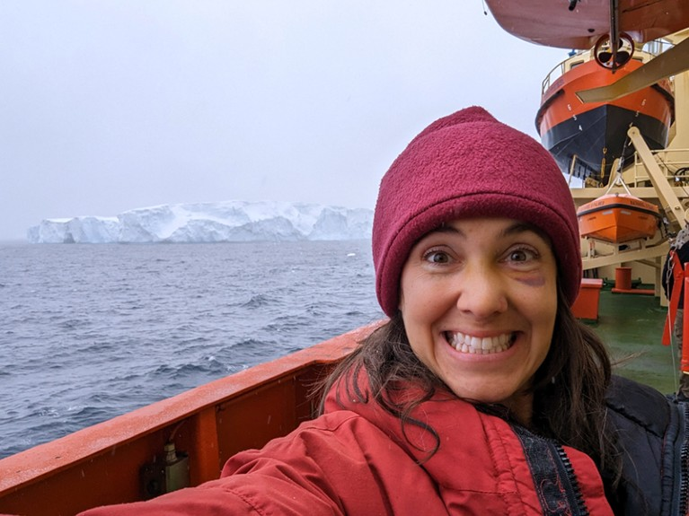
On board the Nathaniel B. Palmer, Virginia Schutte has spotted a glacier.Credit: Virginia Schutte
Assem Gebreal, a final-year medical student and health researcher at Alexandria University, Egypt, is a co-founder of the Global Researcher Club (GRC) , an international network of scientific researchers. The GRC uses WhatsApp for votes, updates, instructions and project management. “It’s like a workspace,” he comments, although Zoom calls are still sometimes needed to kick off important project phases.
The GRC uses a plethora of apps to connect, but Gebreal prefers WhatsApp, thanks to its ability to make direct contact with an audience.Overall, the relatively low data requirements make WhatsApp a useful alternative to Zoom for video calls, says Oluwadamilare Akingbade, a PhD candidate in nursing at the Chinese University of Hong Kong. As the head of a non-governmental organization, the Institute of Nursing Research in Nigeria, he uses the app to communicate with several colleagues and students in Nigeria, where mobile data is relatively expensive.
He uses WhatsApp professionally in several ways, including include supervising his trainees’ research, administering an online journal club and sharing updates about the institute. He appreciates the immediacy of instant messaging for communicating urgent information. “We have a large research community with two WhatsApp groups where we quickly disseminate information from the institute to our members,” he says. “We also use our WhatsApp ‘statuses’ to share updates about our organization.”
Seven ways scientists handle technology challenges in resource-poor settings

However, this doesn’t mean that WhatsApp is a universal tool. Although the platform is accessible in Hong Kong, where Akingbade is based, it is banned in mainland China.

Reaching people on the move
Alongside the benefits of supporting geographically dispersed teams, WhatsApp is also helping scientists whose research participants are located around the world.
Because the platform allows for flexible melding of audio, text and video, researchers can use it to work with people with different literacy levels, communication preferences and schedules. And participants can adjust the app’s settings to retain their profiles even if they change phone numbers, devices or countries, making it easier to keep in touch with them during studies.
One randomized controlled trial of 8,446 migrants in Senegal and Guinea compared survey responses between WhatsApp voice notes and a real-time phone call. Those who responded through WhatsApp were less likely to start the survey, but more likely to complete it once started¹. WhatsApp was also ten times cheaper than the phone call in the largely rural Guinean sample.
Oumarou Hebie, a statistician-economist in Dakar and co-author of the 2022 study, says that WhatsApp has “massive potential” to reach people on the move. He adds that “one practical advantage of WhatsApp voice notes is that the respondents could start the survey any time during the time that it is active”.
Thea de Gruchy, a migration and health researcher at the University of Witwatersrand in Johannesburg, South Africa, has also reached migrant populations using WhatsApp. She collaborated on a scoping review² of how the tool was being used in health-systems research as part of a study of refugees in South Africa who were from sexual and gender minorities (LGBT+).
One lesson was that initial in-person contact with research participants was valuable, even for research that was subsequently carried out through the app. This allowed participants to become more comfortable with using WhatsApp for research, and to work through any tricky aspects.
For example, the research team had initially considered using WhatsApp’s location-sharing function — with participants’ permission — to understand how mobility influenced health-care access. But some participants struggled to turn on the function, whereas others would keep it on all the time.
This raised concerns about security for LGBT+ people in South Africa, de Gruchy says. “In South Africa, many people share cell phones, and cell-phone theft is also quite a big thing.” And owing to the economic impacts of the COVID-19 pandemic, many research participants had sold their mobile phones, keeping their SIM cards to eventually insert into another phone when they had more money.

Room for improvement
Although WhatsApp has opened up possibilities for reaching more people, it has its own sampling limitations. Depending on the context, these might be related to participants’ gender, age or socio-economic status, or to telecommunications infrastructure, de Gruchy says.
Dhadge says the application’s popularity in India for sharing health information raises privacy concerns, but these might be trumped by its usefulness and cost-effectiveness. The tool now has enhanced privacy features, he says, including a view-once option, which prevents a message recipient from looking at a photo or video multiple times.
Gebreal suggests that the app should incorporate an extended the time period for users to delete messages. (At the moment, a sender has two days to delete a message in a chat.)
And de Gruchy warns against complacency about data privacy, and against assuming that WhatsApp’s use of end-to-end encryption is sufficient. It’s important to be “honest about what we don’t know about platforms like WhatsApp and doing research using them”, de Gruchy says. As a private company, “the exact way in which WhatsApp functions is quite opaque to most of us”.
And WhatsApp isn’t welcome everywhere. For instance, the app has been banned in China owing to its encrypted status that limits government access to messages. In 2019, Lebanon tried briefly to tax WhatsApp and other online messaging apps to raise revenue, a move that proved deeply unpopular. And the Ugandan government has taxed WhatsApp as part of a wider social-media tax intended to limit dissent. And there is potential for exclusion of some communities if researchers become overly reliant on WhatsApp. Only 10% of people in Guinea have WhatsApp profiles, for instance.
For WhatsApp surveys specifically, Hebie and colleagues recommend that researchers validate phone numbers before embarking on data collection. The phone numbers in the sample their colleagues used had been collected one year earlier, and 18% of the initial messages failed to reach their destination.

Scientific uses of WhatsApp will continue
de Gruchy feels the pandemic is what caused a growth in the use of the platform for research purposes. “Pre-COVID, we definitely saw a gradual increase in interest in using WhatsApp for research, but also, say, conducting an interview over Skype or over Zoom … But I think that the pandemic really pushed many people to adapt to those methods.” But, Hebie says, “I do not believe that it is a fad linked to COVID-19, and it is likely to continue.”
It’s certainly proved a fruitful experience for the East Antarctic expedition, which finally departed on 20 March. They’ll need to wrap up the trip by mid-May.
The team hasn’t been able to send messages daily, but has come close. The scientists have used it to share details of the research gaps the expedition is seeking to fill, as well as the wonders of Antarctica’s unique environment and more lighthearted content, such as a video of Bik dancing in various rooms on the ship.
Even if some applications of WhatsApp for research are emerging rather than established, Schutte encourages others, “Have a good time, and know that you are doing something great by trying.”
doi: https://doi.org/10.1038/d41586-023-01575-z

References
- Ndashimye, F., Hebie, O. & Tjaden, J. Soc. Sci. Comput. Rev. https://doi.org/10.1177/08944393221111340 (2022).
Article Google Scholar
- Manji, K., Hanefeld, J., Vearey, J., Walls, H. & de Gruchy, T. Health Policy Plan. 36, 774–789 (2021).
Article Google Scholar
Download references

Latest on:
Anonymizing peer review makes the process more just
Career News 26 MAY 23
To diversify the scientific workforce, postdoc recruitment needs a rethink
Career Feature 26 MAY 23
Ghosted in science: how to move on when a potential collaborator suddenly stops responding
Career Column 26 MAY 23

Jobs

Postdoctoral Fellow - The Laboratory of Prof. Naoto Hirano
The long-term objective of the Centre for Oncology and Immunology is to identify druggable cancer targets of recalcitrant malignancies and developi...
Hong Kong (HK)
Centre for Oncology and Immunology

2023 Recruitment notice Shenzhen Institute of Synthetic Biology: Shenzhen, China
The wide-ranging expertise drawing from technical, engineering or science professions...
Shenzhen,China
Shenzhen Institute of Synthetic Biology

Tenure-track Assistant Professor in the field of biomedical sciences and metabolism
UNIL is a leading international teaching and research institution, with over 5,000 employees and 15,500 students split between its Dorigny campus, ...
Lausanne, Canton of Vaud (CH)
University of Lausanne (UNIL)

Tenure Track Assistant Professor in Computational Metagenomics and Microbial Modeling
UNIL is a leading international teaching and research institution, with over 5,000 employees and 15,500 students split between its Dorigny campus, ...
Lausanne, Canton of Vaud (CH)
University of Lausanne (UNIL)

2024 Nanyang Assistant Professorship (NAP)
NTU invites outstanding early-career researchers (postdoctoral fellow or equivalent) to apply for an appointment as a Nanyang Assistant Professor.
Singapore (SG)
Nanyang Technological University (NTU)

Related Articles
- 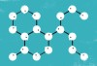How scientists use Slack
- TikTok for physics: influencers aim to spark interest in science
- When Finnish researchers took on the Twitter trolls
- Training: Narrative tools for researchers
- Training: Networking for researchers

Subjects
- Careers
- Society
- Lab life

Sign up to Nature Briefing
An essential round-up of science news, opinion and analysis, delivered to your inbox every weekday.
Top of Form
Email address
Yes! Sign me up to receive the daily Nature Briefing email. I agree my information will be processed in accordance with the Nature and Springer Nature Limited Privacy Policy.
Bottom of Form
Sign up for the Nature Briefing newsletter — what matters in science, free to your inbox daily.
Top of Form
Email address
Bottom of Form
Top of Form
I agree my information will be processed in accordance with the Nature and Springer Nature Limited Privacy Policy.
WhatsApp is a free messaging platform that doesn’t use much data, so scientists can use it both for research and to share their work around the world.Credit: Ivan Romano/Getty
In March, Holly Bik and Virginia Schutte were a few weeks late departing for East Antarctica, where they would collect sea-floor mud to better understand tiny deep-sea invertebrates. The delay was due to a combination of COVID-19 protocols and port congestion.But their time quarantining in a New Zealand hotel as a COVID-19 precaution was productive.
Shortly before being confined to their hotel, Schutte created a WhatsApp community to keep not just her family, but also the general public, updated on their activities on board the research icebreaker Nathaniel B. Palmer. Schutte — who earned a PhD in ecology in 2014 and then became a science communicator, currently based in New Jersey — was contracted by Bik’s laboratory to grow its social-media presence. Schutte had already been using WhatsApp personally. And while waiting to depart from New Zealand, she and the other expedition members used the platform to share updates and get to know each other.
WhatsApp is the world’s most popular messaging application, with two billion monthly users. Former Yahoo programmers Jan Koum and Brian Acton founded the company in 2009, as an Internet-based alternative to text messaging (which occurs over cellular networks). Facebook — now called Meta — purchased WhatsApp in 2014.
The scientists’ use of WhatsApp comes partly out of necessity — there aren’t a lot of options for Internet communication in the Antarctic, Schutte explains. “Space will have better Internet than where we’re going.”
Because of this, common channels for science communication, such as the social-media platforms TikTok and Twitter, would be less likely to work. WhatsApp requires so little mobile data that it can work in the Southern Ocean, explains Bik, a deep-sea biologist at the University of Georgia in Athens. She hadn’t used WhatsApp in any capacity before reaching New Zealand, where the app isn’t especially popular.
Once they realized that they would be able to use WhatsApp aboard the Nathaniel B. Palmer, they had to decide how to do so. A common way for WhatsApp users to interact is in a WhatsApp group — but those can use more data, because users have a number of ways to interact in the group. Schutte and Bik needed to reduce data usage and sharing of information, so they instead opted for WhatsApp Communities, a feature launched in November 2022. A community is a more controlled version of a typical WhatsApp group: only administrators can send messages, and members can’t view each other’s details. Although a community is less interactive, it’s also more manageable.
Collection: Science communication

One reason that the two decided to create a community rather than a group was to limit the number of messages, given the bandwidth restrictions. Another was to protect members’ privacy, including their own, because the group was open to the public. In the first iteration of the group, Schutte and Bik used their personal phone numbers when sending messages. They soon realized that it would be better to use a separate work-only number obtained from Google Voice, which provides free phone numbers that can be used online.
They haven’t come across any similar WhatsApp community for science communication, and are treating this one as an experiment. Bik says, “just like you can’t predict what species you’re going to find when you sample on the bottom, you also can’t predict” the Internet conditions. These depend on factors including weather and location. So they couldn’t be entirely sure that their WhatsApp community, which is called ‘Antarctic Worms’ and has reached more than 240 members, could be sustained.
In the spirit of this experiment, they’re hoping that the results will be useful to others. “How do you do ship-based outreach in these Internet-poor regions that are really important from a climate-change and ecology and evolution perspective?” asks Bik. “We know that people love expeditions and they want to engage with scientists on ships.”

A mix of features
It’s not only aboard research vessels that WhatsApp can be useful for scientists. Because the app is convenient, popular and free to use, researchers have been using it for collaboration, as well as basic communication. Scientists can find interviewees through public posts on the app, and collect data through private messages.
Easily sharing video is another useful aspect. For example, in India — where WhatsApp is very popular — health professionals have used the app to monitor their patients’ inhaler use through video. Nagesh Dhadge, a respiratory physician at Manipal Hospital in Pune, explains, “This was a pilot study exploring use of [a] freely available app for effective remote monitoring of inhaler technique.”
On board the Nathaniel B. Palmer, Virginia Schutte has spotted a glacier.Credit: Virginia Schutte
Assem Gebreal, a final-year medical student and health researcher at Alexandria University, Egypt, is a co-founder of the Global Researcher Club (GRC) , an international network of scientific researchers. The GRC uses WhatsApp for votes, updates, instructions and project management. “It’s like a workspace,” he comments, although Zoom calls are still sometimes needed to kick off important project phases.
The GRC uses a plethora of apps to connect, but Gebreal prefers WhatsApp, thanks to its ability to make direct contact with an audience.Overall, the relatively low data requirements make WhatsApp a useful alternative to Zoom for video calls, says Oluwadamilare Akingbade, a PhD candidate in nursing at the Chinese University of Hong Kong. As the head of a non-governmental organization, the Institute of Nursing Research in Nigeria, he uses the app to communicate with several colleagues and students in Nigeria, where mobile data is relatively expensive.
He uses WhatsApp professionally in several ways, including include supervising his trainees’ research, administering an online journal club and sharing updates about the institute. He appreciates the immediacy of instant messaging for communicating urgent information. “We have a large research community with two WhatsApp groups where we quickly disseminate information from the institute to our members,” he says. “We also use our WhatsApp ‘statuses’ to share updates about our organization.”
Seven ways scientists handle technology challenges in resource-poor settings

However, this doesn’t mean that WhatsApp is a universal tool. Although the platform is accessible in Hong Kong, where Akingbade is based, it is banned in mainland China.

Reaching people on the move
Alongside the benefits of supporting geographically dispersed teams, WhatsApp is also helping scientists whose research participants are located around the world.
Because the platform allows for flexible melding of audio, text and video, researchers can use it to work with people with different literacy levels, communication preferences and schedules. And participants can adjust the app’s settings to retain their profiles even if they change phone numbers, devices or countries, making it easier to keep in touch with them during studies.
One randomized controlled trial of 8,446 migrants in Senegal and Guinea compared survey responses between WhatsApp voice notes and a real-time phone call. Those who responded through WhatsApp were less likely to start the survey, but more likely to complete it once started¹. WhatsApp was also ten times cheaper than the phone call in the largely rural Guinean sample.
Oumarou Hebie, a statistician-economist in Dakar and co-author of the 2022 study, says that WhatsApp has “massive potential” to reach people on the move. He adds that “one practical advantage of WhatsApp voice notes is that the respondents could start the survey any time during the time that it is active”.
Thea de Gruchy, a migration and health researcher at the University of Witwatersrand in Johannesburg, South Africa, has also reached migrant populations using WhatsApp. She collaborated on a scoping review² of how the tool was being used in health-systems research as part of a study of refugees in South Africa who were from sexual and gender minorities (LGBT+).
One lesson was that initial in-person contact with research participants was valuable, even for research that was subsequently carried out through the app. This allowed participants to become more comfortable with using WhatsApp for research, and to work through any tricky aspects.
For example, the research team had initially considered using WhatsApp’s location-sharing function — with participants’ permission — to understand how mobility influenced health-care access. But some participants struggled to turn on the function, whereas others would keep it on all the time.
This raised concerns about security for LGBT+ people in South Africa, de Gruchy says. “In South Africa, many people share cell phones, and cell-phone theft is also quite a big thing.” And owing to the economic impacts of the COVID-19 pandemic, many research participants had sold their mobile phones, keeping their SIM cards to eventually insert into another phone when they had more money.

Room for improvement
Although WhatsApp has opened up possibilities for reaching more people, it has its own sampling limitations. Depending on the context, these might be related to participants’ gender, age or socio-economic status, or to telecommunications infrastructure, de Gruchy says.
Dhadge says the application’s popularity in India for sharing health information raises privacy concerns, but these might be trumped by its usefulness and cost-effectiveness. The tool now has enhanced privacy features, he says, including a view-once option, which prevents a message recipient from looking at a photo or video multiple times.
Gebreal suggests that the app should incorporate an extended the time period for users to delete messages. (At the moment, a sender has two days to delete a message in a chat.)
And de Gruchy warns against complacency about data privacy, and against assuming that WhatsApp’s use of end-to-end encryption is sufficient. It’s important to be “honest about what we don’t know about platforms like WhatsApp and doing research using them”, de Gruchy says. As a private company, “the exact way in which WhatsApp functions is quite opaque to most of us”.
And WhatsApp isn’t welcome everywhere. For instance, the app has been banned in China owing to its encrypted status that limits government access to messages. In 2019, Lebanon tried briefly to tax WhatsApp and other online messaging apps to raise revenue, a move that proved deeply unpopular. And the Ugandan government has taxed WhatsApp as part of a wider social-media tax intended to limit dissent. And there is potential for exclusion of some communities if researchers become overly reliant on WhatsApp. Only 10% of people in Guinea have WhatsApp profiles, for instance.
For WhatsApp surveys specifically, Hebie and colleagues recommend that researchers validate phone numbers before embarking on data collection. The phone numbers in the sample their colleagues used had been collected one year earlier, and 18% of the initial messages failed to reach their destination.

Scientific uses of WhatsApp will continue
de Gruchy feels the pandemic is what caused a growth in the use of the platform for research purposes. “Pre-COVID, we definitely saw a gradual increase in interest in using WhatsApp for research, but also, say, conducting an interview over Skype or over Zoom … But I think that the pandemic really pushed many people to adapt to those methods.” But, Hebie says, “I do not believe that it is a fad linked to COVID-19, and it is likely to continue.”
It’s certainly proved a fruitful experience for the East Antarctic expedition, which finally departed on 20 March. They’ll need to wrap up the trip by mid-May.
The team hasn’t been able to send messages daily, but has come close. The scientists have used it to share details of the research gaps the expedition is seeking to fill, as well as the wonders of Antarctica’s unique environment and more lighthearted content, such as a video of Bik dancing in various rooms on the ship.
Even if some applications of WhatsApp for research are emerging rather than established, Schutte encourages others, “Have a good time, and know that you are doing something great by trying.”
doi: https://doi.org/10.1038/d41586-023-01575-z

References
- Ndashimye, F., Hebie, O. & Tjaden, J. Soc. Sci. Comput. Rev. https://doi.org/10.1177/08944393221111340 (2022).
Article Google Scholar
- Manji, K., Hanefeld, J., Vearey, J., Walls, H. & de Gruchy, T. Health Policy Plan. 36, 774–789 (2021).
Article Google Scholar
Download references

Latest on:
Anonymizing peer review makes the process more just
Career News 26 MAY 23
To diversify the scientific workforce, postdoc recruitment needs a rethink
Career Feature 26 MAY 23
Ghosted in science: how to move on when a potential collaborator suddenly stops responding
Career Column 26 MAY 23

Jobs

Postdoctoral Fellow - The Laboratory of Prof. Naoto Hirano
The long-term objective of the Centre for Oncology and Immunology is to identify druggable cancer targets of recalcitrant malignancies and developi...
Hong Kong (HK)
Centre for Oncology and Immunology

2023 Recruitment notice Shenzhen Institute of Synthetic Biology: Shenzhen, China
The wide-ranging expertise drawing from technical, engineering or science professions...
Shenzhen,China
Shenzhen Institute of Synthetic Biology

Tenure-track Assistant Professor in the field of biomedical sciences and metabolism
UNIL is a leading international teaching and research institution, with over 5,000 employees and 15,500 students split between its Dorigny campus, ...
Lausanne, Canton of Vaud (CH)
University of Lausanne (UNIL)

Tenure Track Assistant Professor in Computational Metagenomics and Microbial Modeling
UNIL is a leading international teaching and research institution, with over 5,000 employees and 15,500 students split between its Dorigny campus, ...
Lausanne, Canton of Vaud (CH)
University of Lausanne (UNIL)

2024 Nanyang Assistant Professorship (NAP)
NTU invites outstanding early-career researchers (postdoctoral fellow or equivalent) to apply for an appointment as a Nanyang Assistant Professor.
Singapore (SG)
Nanyang Technological University (NTU)

Related Articles
- How scientists use Slack
- TikTok for physics: influencers aim to spark interest in science
- When Finnish researchers took on the Twitter trolls
- Training: Narrative tools for researchers
- Training: Networking for researchers

Subjects
- Careers
- Society
- Lab life

Sign up to Nature Briefing
An essential round-up of science news, opinion and analysis, delivered to your inbox every weekday.
Top of Form
Email address
Yes! Sign me up to receive the daily Nature Briefing email. I agree my information will be processed in accordance with the Nature and Springer Nature Limited Privacy Policy.
Bottom of Form
Sign up for the Nature Briefing newsletter — what matters in science, free to your inbox daily.
Top of Form
Email address
Bottom of Form
Top of Form
I agree my information will be processed in accordance with the Nature and Springer Nature Limited Privacy Policy.
https://www.nature.com/articles/d41586-019-01314-3Bottom of Form
Bottom of Form

