https://clarivate.com/wp-content/uploads/2022/05/Tackle-Literature-Reviews-with-Confidence.pdf
https://clarivate.com/webinars/tackle-literature-reviews-with-confidence/?utm_campaign=EM1_Lit_Review_Retention_Webinar_May25%2626_SAR_Global_2022&utm_medium=email&utm_source=Eloqua

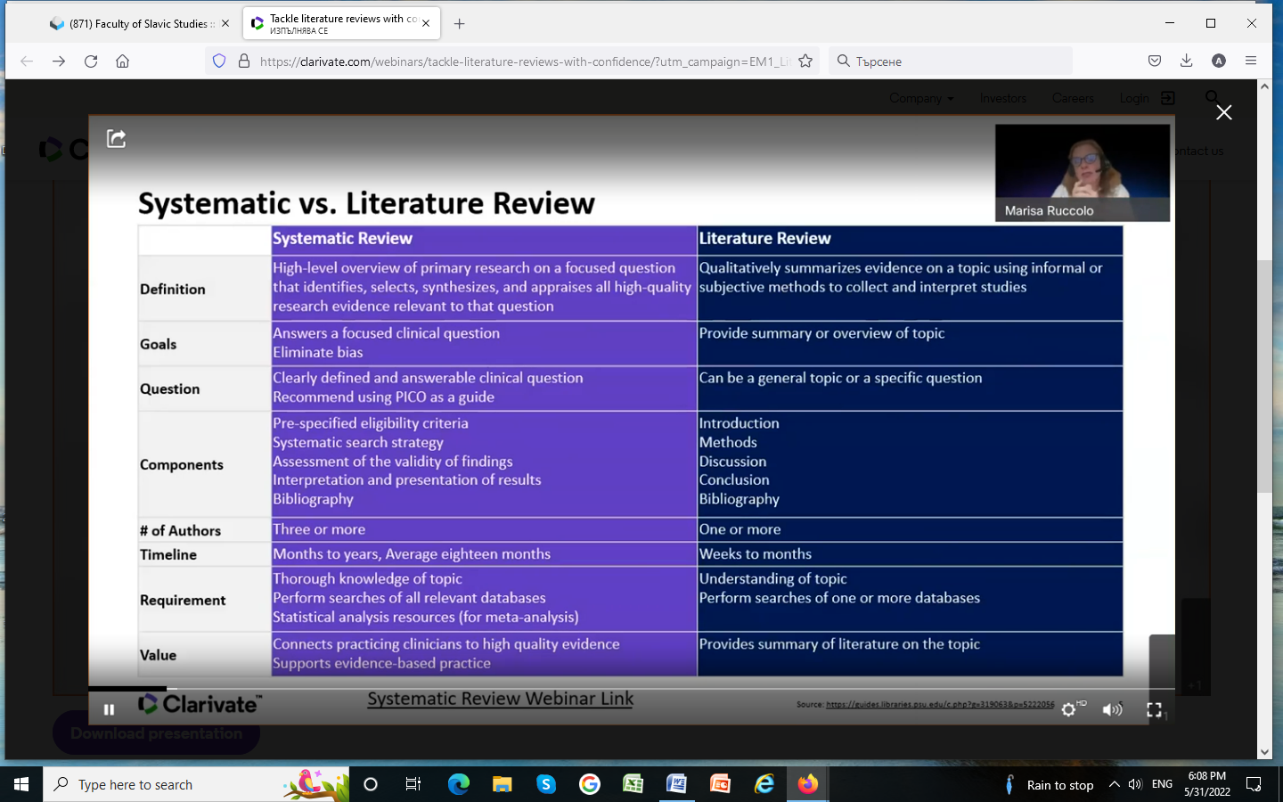

https://clarivate.com/blog/literature-review-definitive-guide/?utm_campaign=EM1_Lit_Review_Retention_Webinar_May25%2626_SAR_Global_2022&utm_medium=email&utm_source=Eloqua

Literature review: your definitive guide
Joanna Wilkinson
Clarivate
Share this article

This is our ultimate guide on how to write a narrative literature review. It forms part of our Research Smarter series.

How do you write a narrative literature review?
Researchers worldwide are increasingly reliant on literature reviews. That’s because review articles provide you with a broad picture of the field, and help to synthesize published research that’s expanding at a rapid pace.
In some academic fields, researchers publish more literature reviews than original research papers. The graph below shows the substantial growth of narrative literature reviews in the Web of Science™, alongside the percentage increase of reviews when compared to all document types.
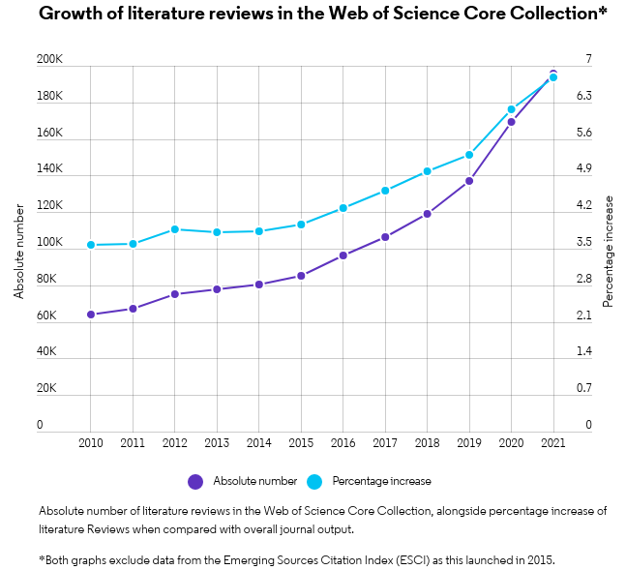
It’s critical that researchers across all career levels understand how to produce an objective, critical summary of published research. This is no easy feat, but a necessary one. Professionally constructed literature reviews – whether written by a student in class or an experienced researcher for publication – should aim to add to the literature rather than detract from it.
To help you write a narrative literature review, we’ve put together some top tips in this blog post.
Best practice tips to write a narrative literature review:

  - Don’t miss a paper: tips for a thorough topic search
  - Identify key papers (and know how to use them)
  - Tips for working with co-authors
  - Find the right journal for your literature review using actual data
  - Discover literature review examples and templates
We’ll also provide an overview of all the products helpful for your next narrative review, including the Web of Science, EndNote™ and Journal Citation Reports™.

1. Don’t miss a paper: tips for a thorough topic search
Once you’ve settled on your research question, coming up with a good set of keywords to find papers on your topic can be daunting. This isn’t surprising. Put simply, if you fail to include a relevant paper when you write a narrative literature review, the omission will probably get picked up by your professor or peer reviewers. The end result will likely be a low mark or an unpublished manuscript, neither of which will do justice to your many months of hard work.
Research databases and search engines are an integral part of any literature search. It’s important you utilize as many options available through your library as possible. This will help you search an entire discipline (as well as across disciplines) for a thorough narrative review.
We provide a short summary of the various databases and search engines in an earlier Research Smarter blog. These include the Web of Science, Science.gov and the Directory of Open Access Journals (DOAJ).
Like what you see? Share it with others on Twitter:
Writing a #LiteratureReview? Check out the latest @clarivateAG blog for top tips (from topic searches to working with coauthors), examples, templates and more Click To Tweet

Searching the Web of Science
The Web of Science is a multidisciplinary research engine that contains over 170 million papers from more than 250 academic disciplines. All of the papers in the database are interconnected via citations. That means once you get started with your keyword search, you can follow the trail of cited and citing papers to efficiently find all the relevant literature. This is a great way to ensure you’re not missing anything important when you write a narrative literature review.
We recommend starting your search in the Web of Science Core Collection™. This database covers more than 21,000 carefully selected journals. It is a trusted source to find research papers, and discover top authors and journals (read more about its coverage here).

Learn more about exploring the Core Collection in our blog, How to find research papers: five tips every researcher should know. Our blog covers various tips, including how to:
- Perform a topic search (and select your keywords)
- Explore the citation network
- Refine your results (refining your search results by reviews, for example, will help you avoid duplication of work, as well as identify trends and gaps in the literature)
- Save your search and set up email alerts
Try our tips on the Web of Science now.

2. Identify key papers (and know how to use them)
As you explore the Web of Science, you may notice that certain papers are marked as “Highly Cited.” These papers can play a significant role when you write a narrative literature review.
Highly Cited papers are recently published papers getting the most attention in your field right now. They form the top 1% of papers based on the number of citations received, compared to other papers published in the same field in the same year.
You will want to identify Highly Cited research as a group of papers. This group will help guide your analysis of the future of the field and opportunities for future research. This is an important component of your conclusion.
Writing reviews is hard work…[it] not only organizes published papers, but also positions t
hem in the academic process and presents the future direction.

Prof. Susumu Kitagawa, Highly Cited Researcher, Kyoto University

3. Tips for working with co-authors
Writing a narrative review on your own is hard, but it can be even more challenging if you’re collaborating with a team, especially if your coauthors are working across multiple locations. Luckily, reference management software can improve the coordination between you and your co-authors—both around the department and around the world.
We’ve written about how to use EndNote’s Cite While You Write feature, which will help you save hundreds of hours when writing research. Here, we discuss the features that give you greater ease and control when collaborating with your colleagues.

Use EndNote for narrative reviews
Sharing references is essential for successful collaboration. With EndNote, you can store and share as many references, documents and files as you need with up to 100 people using the software.
You can share simultaneous access to one reference library, regardless of your colleague’s location or organization. You can also choose the type of access each user has on an individual basis. For example, Read-Write access means a select colleague can add and delete references, annotate PDF articles and create custom groups. They’ll also be able to see up to 500 of the team’s most recent changes to the reference library. Read-only is also an option for individuals who don’t need that level of access.
EndNote helps you overcome research limitations by synchronizing library changes every 15 minutes. That means your team can stay up-to-date at any time of the day, supporting an easier, more successful collaboration.
Start your free EndNote trial today.

4.Finding a journal for your literature review
Finding the right journal for your literature review can be a particular pain point for those of you who want to publish. The expansion of scholarly journals has made the task extremely difficult, and can potentially delay the publication of your work by many months.
We’ve written a blog about how you can find the right journal for your manuscript using a rich array of data. You can read our blog here, or head straight to Endnote’s Manuscript Matcher or Journal Citation Reports to try out the best tools for the job.

5. Discover literature review examples and templates
There are a few tips we haven’t covered in this blog, including how to decide on an area of research, develop an interesting storyline, and highlight gaps in the literature. We’ve listed a few blogs here that might help you with this, alongside some literature review examples and outlines to get you started.
Literature Review examples:
- Aggregation-induced emission
- Development and applications of CRISPR-Cas9 for genome engineering
- Object based image analysis for remote sensing
(Make sure you download the free EndNote™ Click browser plugin to access the full-text PDFs).
Templates and outlines:
- Learn how to write a review of literature, Univ. of Wisconsin – Madison
- Structuring a literature review, Australian National University
- Matrix Method for Literature Review: The Review Matrix, Duquesne University
Additional resources:
- Ten simple rules for writing a literature review, Editor, PLoS Computational Biology
- Video: How to write a literature review, UC San Diego Psychology
Practical Guide Research Smarter
Share this article

